**Video Surveillance System**

using





**A SYNOPSIS**

Submitted in partial fulfillment of the Requirements for the award of the degree of **BACHELOR OF TECHNOLOGY**

IN

**COMPUTER SCIENCE & ENGINEERING**

Specialization in

**Business Analytics and Optimization**

BY

**Name Roll No. SAPID**

ADESH KUMAR GUPTA R103216006 500053000

SHANKEY GUPTA R103216089 500054226

TUSHAR SINGH R103216109 500054191

UTKARSH SANDEEP SINGH R103216110 500053648

Under the guidance of

**Dr. Hitesh Kumar Sharma**



**AP(SG) and PIC**

**Department of Informatics**

School of Computer Science

**University of Petroleum & Energy Studies** Bidholi, via Prem Nagar, Dehradun, UK

September 2019



**School of Computer Science**

**University of Petroleum & Energy Studies, Dehradun**

**Project Proposal Approval Form (2019-20)**

1

**Major Minor**

**Project Title:**

Video Surveillance System using TensorFlow

**Abstract**

Security is one of the major concerns in today's world for everyone. People are very much concerned about it and take the best possible measures to ensure it. Many people be it for their household or for their work organization use the traditional technology of CCTV cameras which record videos for days and months and if any mishappenings take place, they check their CCTV recordings and look for the possible evidences that caused it, but the mishappening has already taken place and damage is already done.

In order to overcome this problem and prevent any mishappenings from taking place we are coming up with an enhanced version of this traditional technology that is a “Video Surveillance System” which will detect any unusual activity and based on it will send a prompt via an SMS or mail to the user for which the user can take appropriate action before the damage being done.

In this way the problems that soldiers face on the border can be avoided and if any unknown human being is detected, instant prompt will be sent and the army people can take sudden action against it and avoid any kind of damage from happening. This will act as a much better solution as there won't be any need to analyse everything again from the past recordings of a CCTV camera after taking place of an unwanted activity. This will help to reduce man power and will be a good safety approach for property and life.

**Introduction:**

We know surveillance is very important and necessary in today's world. Be it safety of people or safety of precious things surveillance plays a huge role in security purposes. The more important the surveillance of human beings is, the equal it is for other tasks like watching over valuables, monitoring operations, employee safety, loss prevention and public safety.

Video Surveillance System is a great answer to all these issues to maintain an even stronger and reliable level of security. It is a model based on deep learning which is able to detect the right objects in live video almost all of the time. This system would be capable of capturing images and videos to find out any unusual activities. This system proves to be an enhanced version of the traditional surveillance systems that were used for security purposes.

Traditional systems continuously recorded and saved video footages for days and months which utilized a lot of battery and storage capacity to store these large video footage, but this  
enhanced Surveillance System will continuously monitor but would record only any unusual changes that happen during its monitoring like theft detection, fire detection.  
As soon as the system catches any unusual activity it immediately takes a step against it and informs the user by sending an SMS or an Image via E-Mail.

**Problem Statement:**

As we all know, for the security purposes, CCTV cameras are installed everywhere but the main problem is that it requires 24X7 human monitoring that is not feasible and also if any happening occurs then it doesn’t send us any alert signals. We can only check manually the previously recorded data. That results in huge loss of life, money and property.

**Literature Review:**

[1] The process of analyzing video sequence is termed as Video Surveillance. Video Surveillance activities can be categorized into 3 types manual, semi-autonomous and fully-autonomous. In fully-autonomous video is taken only is the scene where surveillance is need to be performed. Automatic motion detection which can get better human attention.

[2] Foundation subtraction techniques are generally abused for moving item recognition in recordings in numerous applications, for example, traffic observing, human movement catch, and video surveillance. Step by step instructions to effectively and proficiently model and update the foundation model and how to manage shadows are two of the most recognizing and testing parts of such approaches. The article proposes a broadly useful strategy that joins factual suspicions with the item level information of moving items, clear questions (apparitions), and shadows obtained in the handling of the past casings.

[3] A Bayes choice principle for the arrangement of foundation and the closer view from chosen include vectors is planned. Under this standard, various kinds of foundation items will be arranged from frontal area protests by picking a legitimate component vector. The stationary foundation item is depicted by the shading highlight, and the moving foundation article is spoken to by the shading co-event include. Forefront articles are extricated by melding the arrangement results from both stationary and moving pixels.

[4] Surveillance is a vital piece of security and is utilized everywhere throughout the world to guarantee the wellbeing of resources just as individuals. Despite the fact that surveillance is dubious in certain circumstances. Particularly when associated with surveillance of people it is vital for different errands like looking out for assets, observing tasks, guaranteeing representative wellbeing just as misfortune counteractive action and open security. The TensorFlow Object Detection API is an open-source system that enables you to utilize pre-prepared article location models or make and train new models by utilizing move learning. This is amazingly helpful on the grounds that building an article discovery model without any preparation can be troublesome and can set aside an exceptionally long effort to prepare.

**Objectives:**

1. To train our model with the different objects.
2. To identify the objects from the live video streaming.
3. To send the alert signal in the form of emails, messages, light or sound.

**Methodology:**

* **Theory:**

This project is about automating the surveillance system which will send alerts in

case of any unusual activity.

For the implementation of this technique, we will use some python modules:

**OpenCV:** To use computer camera as video capturing device and for image processing.

**DarkFlow:** To use TensorFlow TFNet module for Object Detection.

* **Approach:**
* Importing specified modules
* Define options to build the model. We are using yolo.cfg model.
* Capture live video through webcam
* Instantiate TFNet class with options.
* Read frames from video until webcam is on.
* Pass these frames into TFNet predict function which will return results containing object label, top left & bottom right coordinates and confidence for each object.
* For each object:

1) Extract top left & bottom right coordinates

2) Store the label

3) Draw rectangle box around that object and specify label

* Show these frames until webcam is on.
* In case of border surveillance, if label is human an alert will be generated.
* Similarly, based on different parameters (predefined) we can generate alerts.

**System Requirements: (Software/Hardware)**

**Hardware:**

RAM- 8GB

Processors- Intel Core i3/i5/i7

HDD- 2GB

**Software:**

Operating System- Windows 10/8.1/8/7/XP | Ubuntu| RedHat

Programming Language- Python

**Schedule: (PERT Chart)**

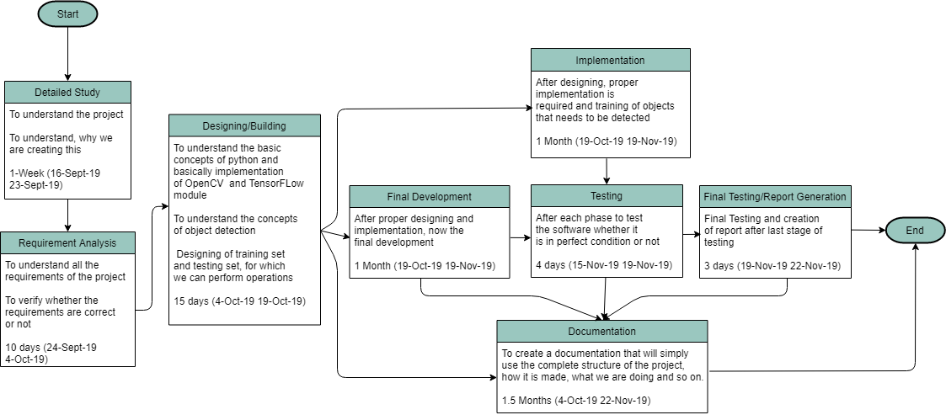

**Fig 1.1 Pert Chart**

**References:**

Documented Reference:

[1] A Survey on Moving Object Detection and Tracking in Video Surveillance System <http://citeseerx.ist.psu.edu/viewdoc/download?doi=10.1.1.645.7492&rep=rep1&type=pdf>

# [2] Detecting moving objects, ghosts, and shadows in video streams

<https://ieeexplore.ieee.org/abstract/document/1233909>

# [3] Foreground object detection from videos containing complex background

# <https://dl.acm.org/citation.cfm?id=957017>

# [4] Simple Surveillance System with the TensorFlow Object Detection API

# <https://towardsdatascience.com/simple-surveillance-system-with-the-tensorflow-object-detection-api-125e04d36446>

**Approved By**

**(Name & Sign) (Name & Sign)**

**Project Guide Department Head**